Algebra 2
Mrs. Kinsler
Syllabus
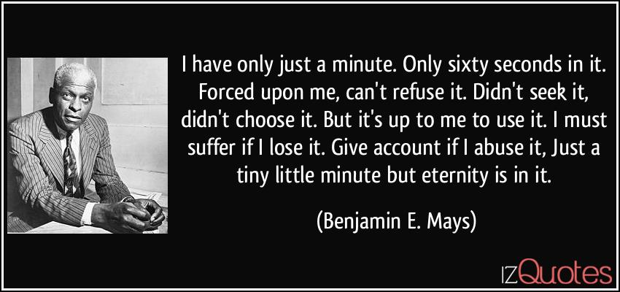
https://izquotes.com/quote/122101
Textbook: Algebra 2. John A. Carter et al. Glencoe Publishing, 2017.
Class requirements:
Paper, pencil, internet access
- Notes are required! You can take notes directly in Google Docs but will need to take a picture of math problems worked out.
- A graphing calculator is necessary for Algebra 2 Texas Instruments has provided an online app for free use of their graphing calculator Please check your Chromebook for the App. There are several online sites that have many features of the graphing calculator:
https://www.meta-calculator.com/
https://www.geogebra.org/graphing?lang=en
https://www.desmos.com/calculator
Communication:
Email address mkinsler@mccormick.k12.sc.us
Google Classroom!!! Many helpful videos are posted on Google Classroom in addition to assignments. Please access this as soon as possible! Parents can send me information to be invited to view the site.
I will use Remind as often as possible to remind students and alert parents of upcoming major assignments.
Classwork- Students are required to attend class either in person or virtually Monday through Thursday. You are expected to log in three to five minutes before class begins. You will be marked tardy if you are late. You will be marked absent if you are not there for most of the time. The class time will be spent teaching concepts, working examples, and practicing problems interactively.

Tests: Chapter tests will be taken Face to Face in class. Virtual students will be required to come to school on the Friday of test week.

Class rules:
All class rules are designed to allow each student to have the opportunity to maximize learning. School rules will be followed!
- Cell phones are to be put on silent or turned off and placed in the phone caddy at the beginning of class. If the phone makes a noise or causes disruption in any way, it will be given to Mr. Salliewhite.
- Students are not to answer questions directed to another student.
- Raise your hand if you have a question.
- See the document in Google Classroom regarding virtual class.

Grades – Grades are categorized as Major or Minor. Chapter tests and Quarterly Notebook grades carry major weight. All other grades such as homework and classwork are minor. Major grades are 60% of the quarter grade. Minor grades are 40% of the quarter grade. A midterm exam will be given at the end of the first quarter. It will be counted as a test grade. A final exam will be given at the end of the semester. The course grade is calculated by averaging the two quarters and the final exam. Each quarter is valued at 40% of the course grade. The exam is 20% of the course grade.
Retest opportunity: Students have two opportunities to take another test to replace a test grade provided the student takes the initial test during the time it is originally administered.
Chapter 0 – The concepts presented are review from previous courses. They will reinforce prerequisite skills. The mastery of these skills is necessary for the success in the course. Some students may not need the review while other students may need more than the work assigned.
First Quarter:
Chapter 1 – Equations are simply mathematical sentences that often have been created to represent a real-world problem. Equations can be solved graphically, numerically, and algebraically. The equations in this chapter will graph as lines. Analyzing the graph helps understand the solution to the real-world situation.
Chapter 2 – The chapter continues with studying the representation of linear equations. Concepts such as slope, domain, range, and linear trend will be mastered.
Chapter 3 – The chapter addresses second degree functions and equations, which are called quadratic functions. There are multiple ways to find solutions to quadratic equations. Students will learn how to determine which method is best for each situation. Transformations of the parent graph will be examined so students can identify the type of transformation by examining the function.
Chapter 4 – Polynomials of different degrees will be analyzed numerically, algebraically, graphically, and verbally. Students will explain terms such as degree, transformation, end behavior, increasing, decreasing, zeros, maximum, minimum, intercepts for each polynomial function.
Chapter 5 – Students will recognize and create inverse functions by graphing and exchanging domain and range of the function. Students will analyze two types of radical functions (square root and cube root) and will learn how to transform the radical functions to power functions.
Second Quarter
Chapter 6 – Students will learn applications of logarithmic and exponential functions. Students will be able to determine growth factor and decay factor based on the analysis of the graph and examination of the function. The chapter expands the concept of exponential functions to study geometric sequences and series. Students will relate exponential functions to logarithmic functions and will analyze data to determine the appropriate best-fitting function.
Chapter 7 – Students will apply math operations involving fractions to include the operations of rational functions. Students will graph rational functions by first identifying asymptotes, holes, x- and y- intercepts.
Chapter 8 – Students will analyze collected data samples and construct frequency tables and compare theoretical probability with experimental probability. Statistical analysis will be used to understand terms such as random sampling and bias.
Chapter 9 – Students will compare ratios of sides of right triangles to observe the consistent relationship between the sides. Trigonometric functions will be graphed on an x,y – axis as well as a unit circle.
Chapter 10 – Students will apply the Pythagorean Theorem to trigonometric functions to determine identities. Students will use the identities to solve trig functions.
Pacing Guide:
Chapter | Title | Number of Days
0 | Preparing for Advanced Algebra | 3
1 | Linear Equations | 8
2 | Linear Relations and Functions | 6
3 | Quadratic Functions | 6
4 | Polynomials and Polynomial Functions | 9
5 | Inverses and Radical Functions | 6
6 | Exponential and Logarithmic Functions | 8
7 | Rational Functions | 6
8 | Statistics and Probability | 6
9 | Trigonometric Funcitons | 6
10 | Trigonometric Identities and Equations | 4

